Note:

We have created this reference document to get more idea about how to run Master file Master file On Linux.

**Running RunDaisy.sh on Linux.**

1. **For the first time when we run the RunDaisy.sh on Linux we need to give permission to shell script file.**
   1. You have to execute “**chmod u+x RunDaisy.sh”** (This will provide the permission to execute the RunDaisy.sh script file, This is only for the first time when you try to run the file.)
2. You have to run the RunDaisy.sh like this for every single time **“./RunDaisy.sh”** to use Daisy(Whenever you run the script on Linux you need to use ./filename such format.)
   1. Note: if you get this error ‘bash: ./RunDaisy.sh: /bin/bash^M: bad interpreter: No such file or directory’
   2. Use this command “**sed -i -e 's/\r$//' RunDaisy.sh”.**

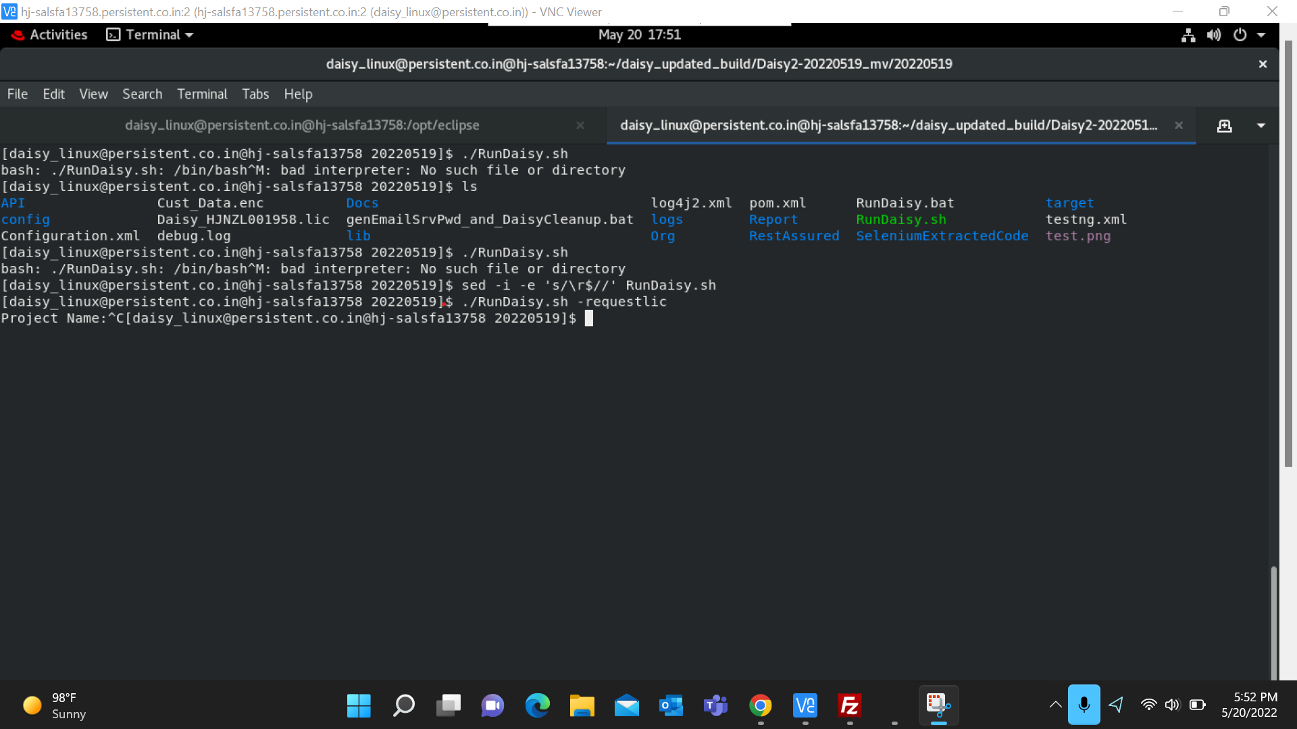

1. To run with different environments.
   1. Syntax :- **./RunDaisy.sh <EnvironmentName> <TestSuiteName/Master fileName>**
2. **./RunDaisy.sh parameter options are below:**

|  |  |
| --- | --- |
| **Command** | **Execution details** |
| ./RunDaisy.sh | It will pick up Default environment and Master.xlsx file. |
| ./RunDaisy.sh UAT | It will pick up UAT environment and Master.xlsx file. |
| ./RunDaisy.sh SmokeTest.xlsx | It will pick up Default environment and SmokeTest.xlsx file. |
| ./RunDaisy.sh UAT RegressionTest.xlsx | It will pick up UAT environment and RegressionTest.xlsx file. |

Note: There shouldn’t be any spaces present in file’s name:

E.g. “New Master SmokeTest.xlsx” is invalid name.

“NewMasterSmokeTest.xlsx” is valid name.

* ./RunDaisy.bat: It will pick up Default environment and master.xlsx file.

* ./RunDaisy.bat SmokeTest.xlsx: It will pick up Default environment and SmokeTest.xlsx

* ./RunDaisy.bat UAT testmain.xlsx: It will pick up Default environment and testmain.xlsx

